John Hutchison

EDPS 785

Final Project

1. I will be using the HSB dataset to build a model that predicts math achievement scores from a variety of student level and school predictors. I will begin by constructing a null model that predicts math achievement score.

I predict that math achievement scores may be affected by the minority status and gender of the student. Model 2 will utilize a random intercepts model to test this hypothesis.

Model 3 will then expand this model to include school size as a predictor variable.

1. Null Model:

Level 1: Math Achievementij = β0j +rij

Level 2: β0j = γ00 + u0j

Model 2:

Level 1: Math Achievementij = β0j + β1j(minority) + β2j(female) + rij

Level 2: β0j = γ00 + u0j

β1j = γ10

β2j = γ20

Model 3:

Level 1: Math Achievementij = β0j + β1j(minority) + β2j(female) + rij

Level 2: β0j = γ00 + γ01(size) + u0j

β1j = γ10

β2j = γ20

1. Null Model:

Model 2:

Model 3:

1. Table 1: Results for all models

When compared to the null model, Model 2 fit the data better significantly. However, adding the school size as a predictor in Model 3 did not result in a significantly better fit to the data. In fact, Model 2 resulted in slightly lower AIC and BIC values than Model 3, suggesting that it is the best fit to the data.

1. Level 1 Residuals Plot:

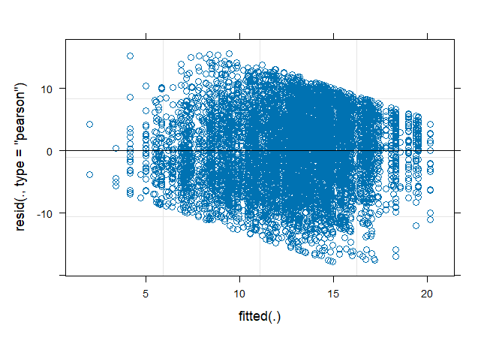

There does not seem to be any pattern in the residuals, so we can assume that independence is met. We see that there is a higher concentration of residuals near 0, so normality also seems to be met.

Level 2 Residuals Plot:

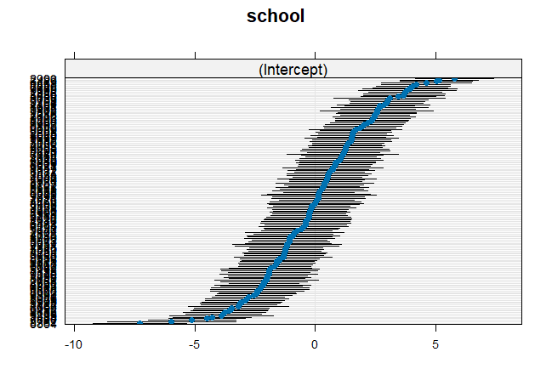

The caterpillar curve is narrow which indicates that the data behaves normally. It is symmetric and has an inflection point in the center which is evidence of homoscedasticity. It is also sigmoidal to linear which is evidence of independence and linearity.

Q-Q Plot:

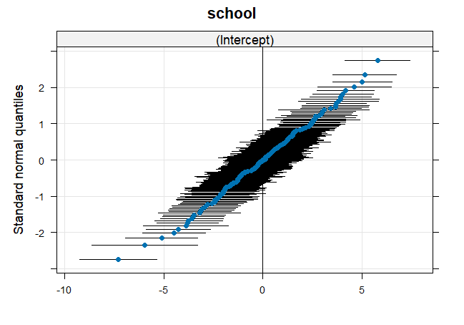

We see that the Q-Q plot curve is a 45-degree angle, which suggests that the data behaves normally.

1. Model 2 Interpretation:

We find a significant impact of minority status and gender in predicting math achievement levels. Women had significantly lower math achievement levels than men (t= -8.294, p<0.05). Minority students also had significantly lower math achievement levels than non-minority students (t= -17.584, p<0.05). All the assumptions for HLM were met, so we can assume that the results of this study are valid. The results of this study show the need for further research into the influence of gender and socioeconomic status on school performance. The disparity between minority and nonminority students and male and female students in math achievement scores may be understood when considering the systemic issues at play in our current society. Centuries of oppression and limited opportunities for women and racial minorities in this country are still affecting those demographics in today’s world. This data highlights a need for increased attention and opportunities for women and minorities in schools.